STARAGILE MAVEN ASSIGNMENT -2

1. **Go to Spring Initializr**:
   * Visit the Spring Initializr website: [Spring Initializr](https://start.spring.io/)
2. **Choose Configuration**:
3. **Download the Spring Boot Project Template**:
   * Click on "Generate" to download the Spring Boot project template (springboot-demo.jar).

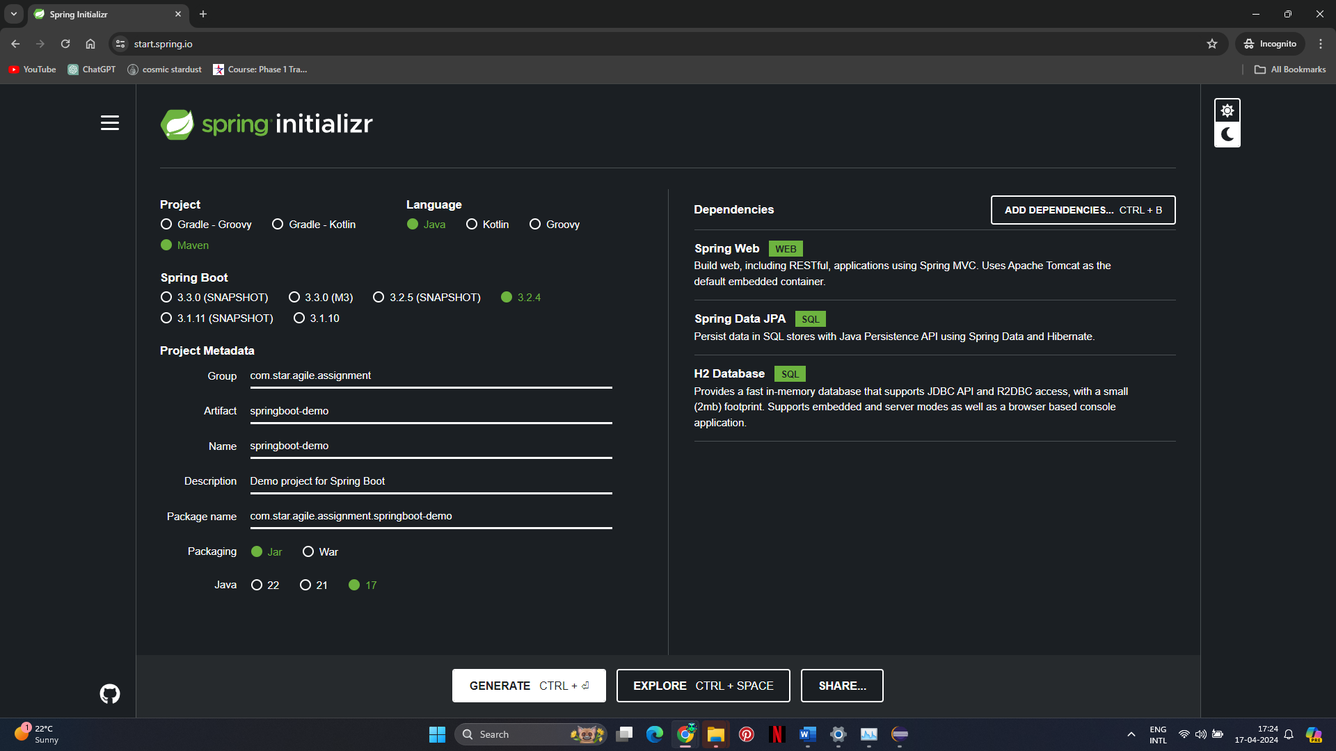

1. **Import Project into Eclipse**:
   * Open Eclipse IDE.
   * Go to File > Import.
   * Select "Existing Maven Projects" and click "Next".

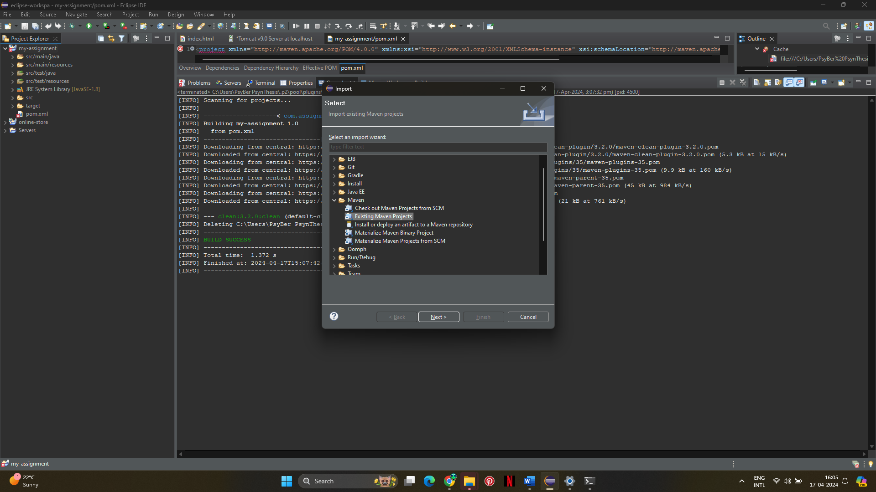

* + Browse to the location where you downloaded the springboot-demo.jar file and click "Finish".
  + Eclipse will import the project and resolve the dependencies automatically.

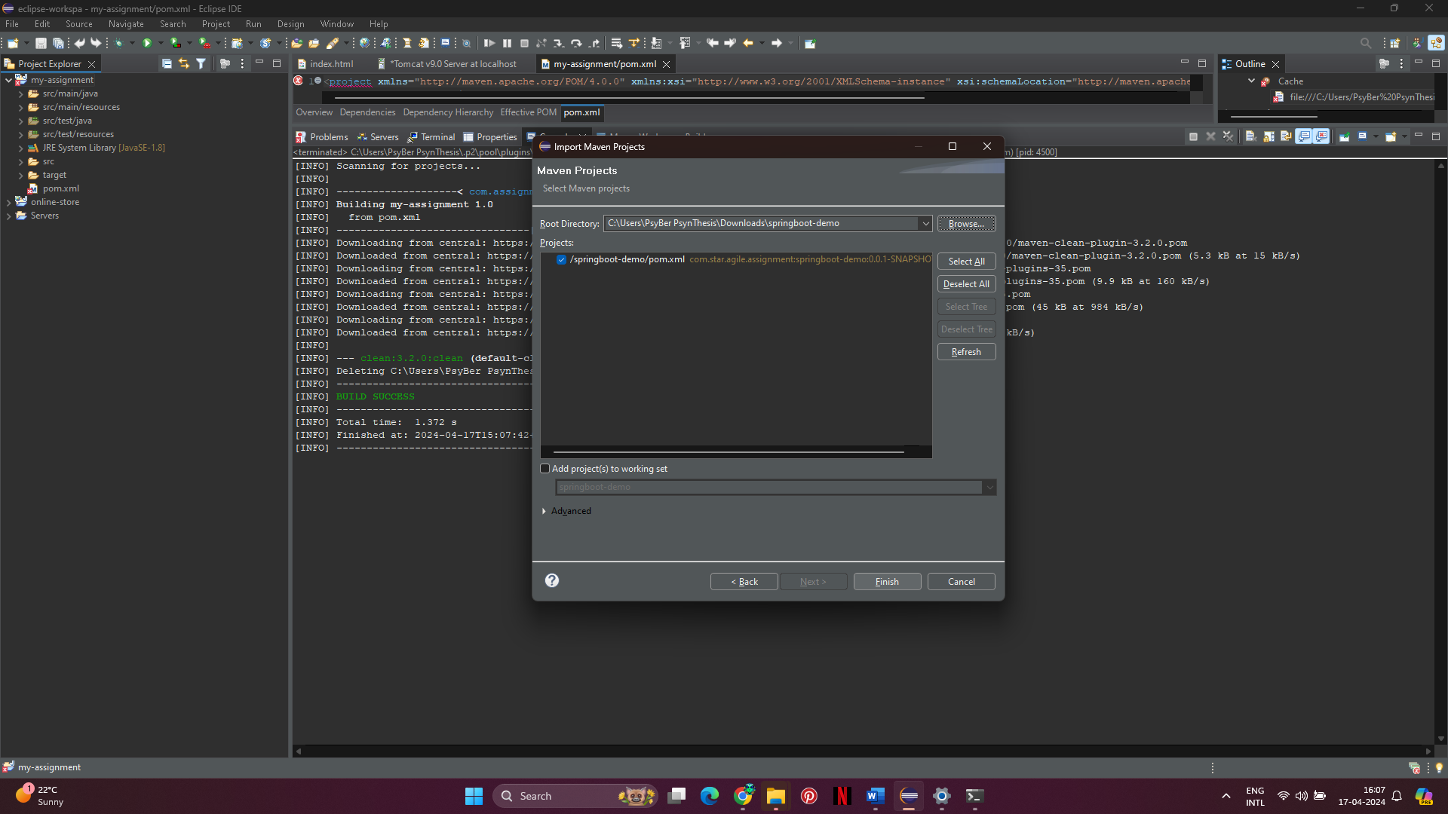

1. **Add index.html File**:
   * Inside the project, create a folder named "static" under the "resources" directory.
   * Add a new file named "index.html" inside the "static" folder.

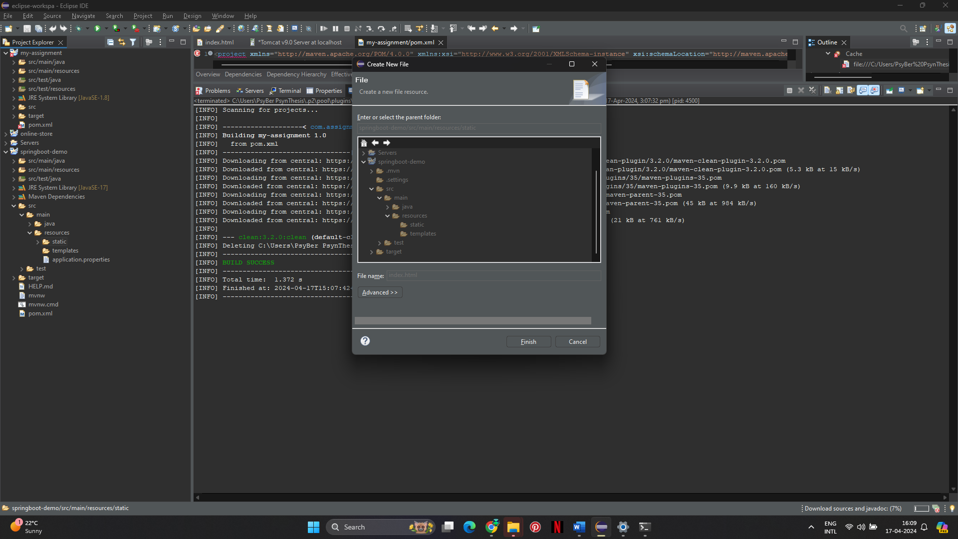

* + Write some HTML code in the index.html file.

1. **Run the Application**:
   * Right-click on the project in Eclipse and select "Run As" > "Spring Boot App".
   * This will start the application, and you should see the Tomcat server starting on port 8080.

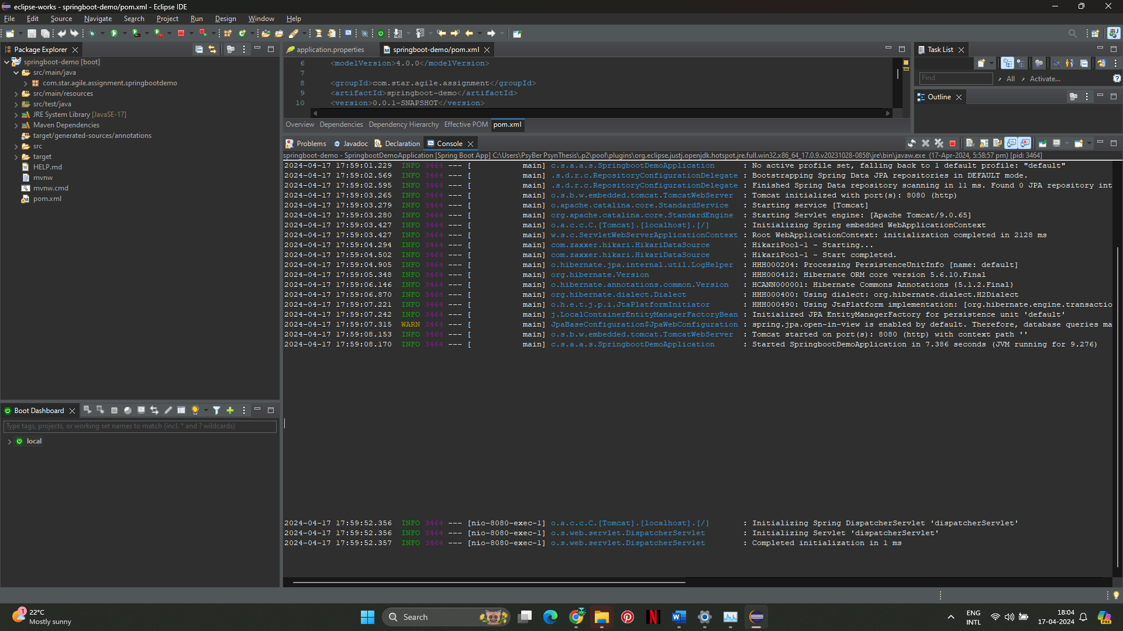

1. **Verify the Application**:
   * Open a web browser.
   * Enter the URL: [http://localhost:8080](http://localhost:8080/)/springboot-demo

